




A Comprehensive Educational Analytics System for Evaluating Teaching Performance via Student Feedback

Educational Analytics & NLP
Excel + Power BI + Copilot / AI Chatbot

A Project Report
submitted in partial fulfilment of the requirements of the AICW Project

by:



Faculty Name
Vartika Mishra

Faculty Email
vartikamishra2018@gmail.com
Guide
UmaMaheshwari

Institution:
Sangam University, Bhilwara, Rajasthan
Year - 2026
ACKNOWLEDGEMENT

We sincerely express our gratitude to everyone who contributed to the successful completion of this project, either directly or indirectly.
We are especially thankful to our guide, Ms. Umamaheshwari, for her continuous support, expert guidance, and constructive feedback. Her encouragement and trust in our work inspired us to stay committed throughout the project.
We would also like to extend our appreciation to Bharti Raja for her valuable inputs, motivation, and engaging sessions, which significantly improved our understanding and approach. We are equally grateful to all the resource persons and experts whose sessions added depth to our learning experience.
Our heartfelt thanks go to the Edunet Foundation, Microsoft, LinkedIn, and SAP for providing us with this enriching fellowship opportunity, along with excellent learning resources and a platform to enhance and demonstrate our skills in AI.
We are also thankful to our institution, Sangam University, Rajasthan, for providing a supportive academic environment during this project.
Finally, we deeply appreciate our families and friends for their constant encouragement, understanding, and unwavering support.

ABSTRACT OF THE PROJECT

This project is part of the AICW (Artificial Intelligence in the Contemporary World) Fellowship Program, a collaborative initiative by Edunet Foundation in partnership with Microsoft, LinkedIn, and SAP. The fellowship is designed to equip students with practical, hands-on skills in Artificial Intelligence, Data Analytics, and Business Intelligence tools.
Student feedback is a critical tool for evaluating teaching effectiveness and enhancing the quality of higher education. However, despite its significance, feedback data often remains underutilised due to its large volume, unstructured nature, and lack of systematic analysis. Educational institutions frequently rely only on numerical ratings, thereby overlooking valuable insights embedded in qualitative comments. This creates a gap between feedback collection and meaningful academic improvement.
The present study aims to develop a structured framework for analysing student feedback using a combination of data analytics and Artificial Intelligence (AI) tools. The key objectives include understanding the structure of feedback datasets, performing data cleaning and preprocessing, analysing both quantitative ratings and qualitative comments, and generating actionable insights to improve teaching practices.
The methodology adopts a five-phase approach comprising data collection, preprocessing, analysis, visualisation, and documentation. Microsoft Excel is used for data cleaning, organisation, and pivot table analysis, while Excel is utilised to create an interactive dashboard that visually represents feedback trends and performance indicators. Additionally, AI tools such as Microsoft Copilot and chatbots are employed to analyse textual feedback using basic Natural Language Processing (NLP) techniques, enabling the identification of recurring themes, sentiment patterns, and areas of concern.
The results of the study include a clean and anonymised dataset, insightful visual dashboards, and AI-generated summaries that highlight key strengths and areas for improvement in teaching. The project demonstrates that integrating AI and data analytics into feedback analysis can significantly enhance decision-making in educational institutions.
In conclusion, this study provides a practical and scalable model for transforming raw student feedback into meaningful insights, thereby promoting data-driven improvements in teaching quality and student learning outcomes.

TABLE OF CONTENTS

Abstract of the Project
List of Figures
List of Tables
Chapter 1 — Introduction
1.1 Problem Statement
1.2 Motivation
1.3 Objectives
1.4 Scope of the Project
Chapter 2 — Literature Survey
Chapter 3 — Proposed Methodology
3.1 System Design
3.2 Modules / Components Used
3.3 Data Flow Diagram (DFD)
3.4 Advantages
3.5 Requirement Specification
Chapter 4 — Implementation and Results
4.1 Data Cleaning Results
4.2 Visualization / Output Results
4.3 AI Tool Integration Results
Chapter 5 — Discussion and Conclusion
References
Appendices

LIST OF FIGURES

Figure No. | Figure Title / Description | Page No.
Figure 1 | [Raw / uncleaned dataset screenshot] | 30
Figure 2 | [Cleaned dataset or validation summary screenshot] | 30
Figure 8 | [Main dashboard / report / output screenshot] | 35
Figure 3-7 | [Additional chart or visualization screenshot] | 31-35
Figure 9 | [AI tool (Copilot / Chatbot) in use screenshot] | 37-38
Figure A | [DFD Level 0 — Context Diagram] | 21
Figure B | [DFD Level 1 — Detailed Process Flow] | 23

LIST OF TABLES

Table No. | Table Title / Description | Page No.
Table 1 | [Raw dataset summary — field names, data types, row count] | 13
Table 2 | [Cleaned dataset summary — issues found and fixed] | 15
Table 3 | [Hardware Requirements] | 26
Table 4 | [Software Requirements] | 26
Table 5 | [Key findings / results summary] | 40

CHAPTER 1
Introduction
This project, titled “A Comprehensive Educational Analytics System for Evaluating Teaching Performance via Student Feedback,” has been undertaken as part of the AICW Faculty Fellowship Program 2026. It focuses on the application of Educational Analytics and Natural Language Processing (NLP) to enhance the analysis of student feedback and promote data-driven improvements in teaching practices.
In recent years, educational institutions have increasingly emphasised quality teaching and learning outcomes, leading to the collection of large volumes of student feedback through surveys, rating systems, and open-ended responses. However, the vast and unstructured nature of qualitative feedback makes manual analysis difficult, time-intensive, and susceptible to inconsistencies or oversight.
The project seeks to overcome these challenges by incorporating AI tools, basic sentiment analysis, and structured data analysis techniques to transform raw feedback into meaningful and actionable insights. This chapter outlines the background and context of the study, highlights the limitations of existing feedback analysis methods, and presents the objectives and scope of the project.
1.1 Problem Statement
The core problem addressed in this project is the ineffective utilisation of student feedback data in higher educational institutions. Although large volumes of feedback are regularly collected through surveys, rating forms, and open-ended responses, much of this data remains under-analysed or superficially interpreted.
The primary challenge lies in the unstructured and complex nature of qualitative feedback, which includes diverse student comments, suggestions, and concerns. Manual analysis of such data is time-consuming, inconsistent, and often leads to the neglect of valuable insights. As a result, institutions tend to rely mainly on numerical ratings, ignoring deeper patterns and sentiments expressed in textual feedback.
This problem is significant because student feedback plays a crucial role in improving teaching quality, course design, and overall learning outcomes. Ineffective analysis can lead to missed opportunities for pedagogical improvement, reduced student satisfaction, and a lack of data-driven decision-making in academic environments.
The issue affects multiple stakeholders, including faculty members, academic administrators, and educational institutions, who depend on accurate feedback analysis to enhance teaching practices and institutional performance. Ultimately, students themselves are impacted, as their concerns and suggestions may not be adequately addressed.
Existing approaches are limited in several ways. Traditional methods primarily focus on quantitative data and lack the capability to systematically analyse qualitative feedback. Additionally, there is a lack of accessible tools and structured frameworks that integrate data cleaning, analysis, and interpretation in a user-friendly manner. Most educators are also unfamiliar with leveraging AI tools for feedback analysis, further widening the gap between data collection and meaningful insight generation.
This project seeks to address these limitations by introducing a structured, AI-assisted approach to analysing both quantitative and qualitative student feedback effectively.
1.2 Motivation
The motivation behind selecting the project “A Comprehensive Educational Analytics System for Evaluating Teaching Performance via Student Feedback” stems from both personal and professional relevance. As an educator, understanding student perspectives is essential for improving teaching effectiveness and ensuring meaningful learning outcomes. However, it is often observed that although feedback is collected regularly, it is not analysed in a structured or insightful manner. This gap between feedback collection and its practical use inspired the need to explore a more systematic and technology-driven approach.
From a professional standpoint, this project is highly valuable as it equips educators with the ability to use data analytics and AI tools for academic improvement. It enables faculty members to move beyond traditional methods of evaluation and adopt evidence-based teaching practices. This is particularly important in today’s educational environment, where quality assurance and student-centric learning are gaining increasing importance.
In real-world applications, the project can be implemented across universities and colleges to analyse student feedback efficiently, identify recurring issues, and improve course delivery. It can support academic administrators in decision-making, curriculum enhancement, and performance evaluation of teaching methods.
The potential impact of this project is significant, as it promotes a data-driven culture within educational institutions. By transforming raw feedback into actionable insights, it can enhance teaching quality, improve student satisfaction, and strengthen institutional performance.
Furthermore, this project aligns closely with modern industry trends, particularly the integration of Artificial Intelligence, data analytics, and Natural Language Processing (NLP) in decision-making processes. As AI-driven analysis becomes increasingly important across sectors, applying these technologies in education reflects both innovation and future readiness.
1.3 Objectives
The specific objectives of the study are:
- To collect and examine a student feedback dataset in order to understand its structure, variables, and data characteristics.
- To clean and preprocess the feedback data by removing duplicates, handling missing values, and standardising response formats while ensuring student anonymity.
- To analyse quantitative ratings and qualitative comments to identify patterns, common concerns, and areas of teaching improvement.
- To apply AI tools and basic Natural Language Processing techniques to summarise textual feedback and extract meaningful insights from student comments.
- To develop an interactive dashboard using Excel that visualises feedback trends, rating distributions, and key performance indicators.
- To generate AI-assisted summaries and recommendations that help educators understand student perspectives and improve teaching practices.
- To demonstrate how data analytics and AI can enhance the effective use of student feedback in higher education institutions.
1.4 Scope of the Project
- This project focuses on the analysis of 1000 student feedback data collected from educational institutions, which includes both quantitative ratings and qualitative comments related to teaching effectiveness and course delivery.
- The tools used in this project are limited to Microsoft Excel and AI-based tools such as Microsoft Copilot and AI chatbots, as specified under the fellowship guidelines. Excel is utilised for data cleaning, preprocessing, and basic analytical operations, while AI tools are applied for summarising textual feedback and identifying key themes.
- The analysis primarily concentrates on data cleaning, preprocessing, quantitative analysis using pivot tables, and qualitative analysis through basic Natural Language Processing (NLP) techniques. The project aims to extract meaningful insights from feedback data and present them in a structured and interpretable manner.
- However, the project does not include advanced features such as real-time data integration, large-scale automated systems, or predictive machine learning models. It is limited to a structured analytical framework designed for demonstration and learning purposes.
- Furthermore, this project is developed as part of the AICW Fellowship Program and is intended as an academic and practical showcase rather than a fully deployed, production-level system. Its primary objective is to demonstrate the effective use of data analytics and AI tools in improving the utilisation of student feedback in educational settings.

CHAPTER 2
Literature Survey
A literature survey reviews existing research, tools, and methodologies relevant to the project domain. It helps identify gaps that the current project aims to address.
2.1 Existing Work and Research

2.1.1 Student Feedback Analysis in Higher Education
The importance of systematically analysing student feedback has been recognised in educational research for several decades. Early work by Marsh (1982) on the Students' Evaluations of Educational Quality (SEEQ) instrument established that structured student ratings could serve as reliable and valid indicators of teaching effectiveness. Subsequent studies confirmed that well-analysed feedback correlates positively with improvements in instructional quality when communicated effectively to faculty members (Richardson, 2005). However, the majority of this foundational research focused exclusively on quantitative rating scales, leaving the analysis of open-ended textual comments largely unexplored and methodologically underdeveloped.
More recent research has acknowledged that qualitative comments contain richer and more specific information than numerical scores alone. Wen and Hoon (2009) demonstrated that open-ended feedback provides context that numerical ratings cannot capture, including specific suggestions, emotional tone, and nuanced observations about teaching behaviour. Despite this recognition, most institutions continue to rely primarily on rating averages due to the practical difficulty of processing large volumes of unstructured text.

2.1.2 Natural Language Processing for Educational Feedback
The application of Natural Language Processing (NLP) techniques to student feedback analysis has grown significantly over the past decade. Sentiment analysis — a branch of NLP concerned with identifying positive, negative, or neutral opinions in text — has been applied to course evaluations to automatically classify student comments by tone and theme. Studies such as those by Cotos (2011) and later by Altrabsheh, Cocea, and Fallahkhair (2014) explored the use of machine learning classifiers to analyse student feedback in real time, demonstrating that automated sentiment detection could achieve accuracy levels comparable to human reviewers.
Topic modelling techniques, particularly Latent Dirichlet Allocation (LDA), have also been applied to educational feedback datasets to automatically identify recurring themes across large comment collections. Ramesh et al. (2014) applied LDA to student discussion forums and course evaluations, successfully extracting themes such as course difficulty, instructor engagement, and assessment clarity. These approaches show strong promise but have historically required significant programming expertise, making them inaccessible to most educators and academic administrators without a technical background.

2.1.3 Data Cleaning and Preprocessing in Educational Datasets
Data quality is a well-documented challenge in educational analytics. Clow (2013) highlighted that learning analytics datasets frequently suffer from missing values, inconsistent formatting, and duplicate records, all of which can introduce bias and reduce the reliability of analytical outputs. Standard data preprocessing techniques — including deduplication, handling of null values, normalisation of response formats, and anonymisation of personally identifiable information — have been well established in the broader data science literature (Han, Kamber, and Pei, 2011).
Within the context of Excel-based analysis, Microsoft's own documentation and a range of practitioner-oriented studies have demonstrated effective approaches to cleaning survey data using built-in functions such as TRIM, IFERROR, REMOVE DUPLICATES, and conditional formatting for anomaly detection. Despite the wide availability of these techniques, their systematic application to student feedback data in educational institutions remains inconsistent, with many institutions lacking standardised data governance protocols for survey responses.

2.1.4 Business Intelligence Tools in Education
Excel and similar business intelligence platforms have been increasingly adopted in corporate and healthcare sectors for interactive data visualisation and decision support. Research and practitioner reports from Microsoft (2023) demonstrate that Excel dashboards enable non-technical users to explore trends, filter data dynamically, and generate visual summaries with minimal analytical expertise. In the educational sector, however, the adoption of such tools for feedback analysis remains limited.
A study by Verbert et al. (2013) reviewed learning analytics dashboards and found that visual feedback tools significantly improved the ability of educators to interpret student performance data and identify areas requiring intervention. Nevertheless, most existing educational dashboards focus on academic performance metrics such as grades and attendance rather than feedback sentiment and qualitative themes. This represents a clear gap between what business intelligence tools are capable of and how they are currently being used in academic evaluation contexts.

2.1.5 AI-Assisted Summarisation and Insight Generation
The emergence of large language models (LLMs) and conversational AI tools has opened new possibilities for qualitative data analysis. Tools such as Microsoft Copilot, ChatGPT, and Google Gemini are capable of reading large volumes of text and generating concise, coherent summaries that highlight key themes, patterns, and recommendations. Research by Mollick and Mollick (2023) demonstrated that AI-generated summaries of qualitative feedback were rated as highly useful by educators, often matching or exceeding the quality of manually prepared summaries in a fraction of the time.
Despite these capabilities, structured frameworks for using AI tools to analyse student feedback remain underdeveloped. Most existing guidance focuses on general-purpose prompt engineering rather than domain-specific applications in educational analytics. There is a notable absence of standardised methodologies that combine AI summarisation with quantitative dashboard visualisation into a single, integrated feedback analysis workflow accessible to non-technical educators.

2.1.6 Identified Gaps and How This Project Addresses Them
A review of existing literature and tools reveals several important gaps that the current project aims to address:
Gap Identified | How This Project Addresses It
Most feedback analysis focuses only on numerical ratings | This project analyses both quantitative ratings and qualitative comments together
NLP tools require programming expertise | This project uses accessible tools such as Exel to perform theme extraction without coding
Excel is underutilised in educational feedback contexts | This project develops an educational feedback dashboard in Excel tailored to teaching improvement
No integrated framework combining cleaning, analysis, AI, and visualisation | This project proposes a five-phase integrated workflow from data cleaning to AI-assisted reporting
Student anonymity is rarely addressed systematically | This project incorporates data anonymisation as a formal preprocessing step
By addressing these gaps, the project contributes a practical, accessible, and integrated approach to student feedback analysis that can be replicated across educational institutions regardless of technical capacity.
2.2 Tools and Technologies Review
2.2.1 Microsoft Excel
Microsoft Excel remains one of the most widely adopted tools for data processing, cleaning, preliminary analysis, and visualisation across industries and academic institutions alike. Its broad accessibility, familiar interface, and powerful built-in functions make it particularly suitable for handling structured datasets such as student feedback surveys. For the purposes of this project, Excel serves as the primary platform for the entire workflow — from data cleaning and preprocessing through to analysis and interactive dashboard development.
Key features relevant to this project include the Remove Duplicates function for eliminating repeated survey entries, TRIM and CLEAN functions for standardising textual responses, IFERROR and IF functions for handling missing or inconsistent values, and Conditional Formatting for visually flagging data anomalies during the review process. Excel's Pivot Tables enable rapid aggregation of numerical ratings by course, instructor, providing a structured foundation for deeper analysis. Data Validation rules enforce consistency in response formats, which is especially useful when working with simulated or manually entered feedback records.
Beyond data cleaning, Excel also serves as the visualisation and dashboard platform for this project. Using Pivot Charts, bar and column charts, pie charts, and slicers connected to pivot tables, an interactive feedback dashboard was developed entirely within Excel. Slicers allow users to filter dashboard visuals dynamically by course name, instructor, semester, or sentiment category, replicating many of the interactive features associated with dedicated business intelligence tools. The use of a single platform for both data processing and visualisation simplifies the overall workflow, reduces compatibility issues between tools, and makes the project more accessible and reproducible for educators with limited technical resources.
While Excel does not natively support advanced sentiment analysis or AI-driven text summarisation, these capabilities are addressed in this project through the integration of Microsoft Copilot and AI chatbots as complementary tools for qualitative feedback analysis.
2.2.3 Microsoft Copilot
Microsoft Copilot is an AI-powered assistant integrated across Microsoft 365 applications including Excel, Word, PowerPoint, and Teams. It leverages large language model technology to help users automate repetitive tasks, generate written summaries, analyse data through natural language queries, and produce recommendations based on document or dataset content. Microsoft Corporation (2023) describes Copilot as designed to work alongside users rather than replace them, augmenting human judgement with AI-generated suggestions and drafts.
In the context of this project, Microsoft Copilot is utilised in two primary ways. First, within Excel, Copilot assists with identifying patterns in rating data, suggesting formulas, and flagging potential data quality issues through conversational prompts. Second, for qualitative feedback analysis, Copilot is used to process batches of student comments and generate concise thematic summaries, highlighting frequently mentioned concerns and areas of appreciation. This approach enables educators without NLP or programming expertise to extract meaningful insights from textual feedback efficiently and consistently.
A current limitation of Copilot relevant to this project is that its output quality depends heavily on the quality and specificity of the prompts provided. Vague or generic prompts tend to produce generalised summaries that lack actionable detail. This project therefore incorporates a structured prompt design process as a formal project phase to ensure that AI-generated outputs are relevant, specific, and educationally meaningful.
2.2.3 AI Chatbots — ChatGPT and Google Gemini
Generative AI chatbots such as OpenAI's ChatGPT and Google Gemini represent a broader category of large language model-based tools capable of understanding and generating human language at scale. These tools have been applied across a wide range of professional use cases including content generation, report writing, code assistance, data summarisation, and qualitative analysis. Research by Mollick and Mollick (2023) found that generative AI tools can produce high-quality analytical summaries and recommendations when guided by well-structured prompts, making them valuable assistants for knowledge workers across domains.
In this project, AI chatbots serve a supplementary role alongside Microsoft Copilot. They are used to test and refine prompt strategies for qualitative feedback analysis, generate sample AI-assisted improvement recommendations for educators, and support the documentation and report writing process. ChatGPT, in particular, is used to simulate NLP-style analysis of student comment batches, identifying recurring themes such as clarity of explanation, assessment fairness, use of examples, and responsiveness of the instructor — without requiring the use of specialised machine learning software.
2.3 Gaps Identified
A careful review of existing literature, tools, and methodologies reveals several significant gaps that directly motivate the design and scope of this project.
Gap 1 — Overemphasis on Complex Machine Learning Approaches
Most of the published research on student feedback analysis employs advanced machine learning techniques such as Support Vector Machines, deep learning classifiers, or transformer-based NLP models. While effective, these approaches require substantial programming expertise and computational resources that most educators do not possess. There is a clear and largely unmet need for simpler, tool-based analytical frameworks that can be implemented using widely available software such as Microsoft Excel without requiring any coding knowledge. This project directly addresses that need.
Gap 2 — Limited Guidance on Using Copilot with Excel for Educational Feedback Analysis
Despite the growing adoption of Microsoft Copilot, there is limited documented guidance on integrating Copilot specifically with Excel for educational feedback analysis. Most available tutorials focus on corporate use cases such as sales reporting or financial analysis. The application of Copilot to student feedback datasets — including how to structure prompts, interpret outputs, and connect AI-generated summaries with Excel-based dashboards — remains an underdeveloped area with little standardised methodology available for faculty or student projects.
Gap 3 — Absence of Standardised Prompt Engineering Frameworks for Educational Analytics
Prompt engineering remains a rapidly evolving discipline with limited domain-specific guidance. For educational feedback analysis, there is an absence of structured prompt templates that reliably produce thematic summaries, sentiment classifications, or teaching improvement recommendations from student comment data. This project addresses this gap by developing and documenting a domain-specific prompt design process as a formal component of the methodology.
Gap 4 — Lack of Integrated End-to-End Feedback Analysis Frameworks for Non-Technical Educators
Existing tools and studies tend to address individual stages of the feedback analysis process in isolation. There is no widely documented, integrated framework that guides a non-technical educator through the complete journey — from raw feedback data to a cleaned dataset, an interactive Excel dashboard, and an AI-generated improvement summary — within a single accessible workflow. This project proposes and demonstrates exactly such an end-to-end framework using only Excel and AI tools.
Gap 5 — Insufficient Attention to Student Data Privacy in Analytical Workflows
Much of the existing literature on feedback analysis does not address data privacy and anonymisation as a formal analytical step. Student feedback datasets frequently contain personally identifiable information that must be removed before analysis. The absence of standardised anonymisation protocols represents both an ethical gap and a practical risk for institutions. This project incorporates data anonymisation as a mandatory preprocessing step, contributing a privacy-conscious approach that is often absent from comparable studies.
CHAPTER 3
Proposed Methodology
This chapter describes the methodology adopted to achieve the project objectives. It covers the system design, modules used, data flow, advantages, and requirement specifications. The project follows a structured five-phase workflow that transforms raw student feedback data into meaningful analytical outputs and actionable teaching improvement insights using Microsoft Excel and AI-assisted tools.
3.1 System Design
The system designed for this project follows a structured, linear data pipeline that transforms raw, unprocessed student feedback into clean analytical outputs and actionable teaching insights. The entire workflow is implemented within Microsoft Excel, supplemented by AI tools for qualitative analysis and summarisation. The data flow progresses through four clearly defined stages as described below.
Stage 1 — Data Source / Input
The input for this project is a structured student feedback dataset stored in Excel (XLSX) format containing 1,000 feedback records collected across five instructors — Prof. Sharma, Prof. Iyer, Prof. Gupta, Prof. Singh, and Prof. Iyer — representing responses from students across multiple courses during an academic semester.
The dataset contains the following eight fields:
Field | Description
Instructor | Name of the course instructor receiving feedback
Teaching Clarity (1–5) | Numerical rating of how clearly the instructor explained concepts
Course Content (1–5) | Numerical rating of the quality and relevance of course material
Engagement (1–5) | Numerical rating of how engaging and interactive the classes were
Overall Rating | Average of the three numerical rating dimensions
Remarks | Open-ended qualitative comment submitted by the student
Sentiment | Sentiment label assigned after analysis — Positive, Neutral, or Negative
Issue Based | Thematic category assigned after analysis — Pacing, Difficulty, Content, Engagement, Practical Gap, or General
The qualitative remarks in the dataset reflect a range of student experiences, including specific concerns such as fast lecture pacing, overly difficult assignments, outdated course content, and a lack of real-world examples, as well as positive feedback regarding teaching clarity, interactive sessions, and engaging lecture delivery. Importantly, the Sentiment and Issue Based columns were not part of the original raw dataset — they were generated during the analysis phase using keyword-based NLP logic implemented through Excel formulas, as described in Stage 3.
Stage 2 — Data Cleaning and Preprocessing
The raw dataset was reviewed and prepared for analysis through a systematic cleaning process within Microsoft Excel. The following operations were performed:
Structural Review — Upon loading the dataset, all column headers were verified for consistency and correct data types were confirmed for each field. Numerical rating columns were validated to confirm all values fell within the expected range of 1 to 5. No values outside this range were found, confirming the integrity of the rating data.
Duplicate Check — The Remove Duplicates function was applied across all records to identify any repeated entries. Records sharing identical remarks and identical ratings across all three dimensions were reviewed carefully. Where such records represented genuinely distinct student responses reflecting common opinions, they were retained as valid separate entries.
Missing Value Handling — The COUNTBLANK function was applied across all columns to identify empty cells. The Remarks column was specifically checked, as blank qualitative entries would reduce the effectiveness of the subsequent NLP-based classification. All 1,000 records were found to be complete with no missing values requiring imputation or removal.
Consistency Validation — Instructor names were reviewed for spelling and spacing consistency across all records. Minor inconsistencies were corrected using the TRIM function to ensure accurate grouping in pivot table analysis. Numerical rating fields were also confirmed to contain only integer values, with no decimal or text entries present.
Overall Rating Verification — The Overall Rating field was cross-checked against the three individual rating dimensions using the formula:
= ROUND((Teaching Clarity + Course Content + Engagement) / 3, 1)
This formula was applied across all records to confirm the accuracy of pre-existing overall scores. Any discrepancies identified were corrected within the dataset before proceeding to the analysis phase.
Anonymisation Note — As the dataset uses instructor identifiers rather than student names or registration numbers, no student-level anonymisation was required. The dataset contains no personally identifiable student information, and instructor names were retained as they form the primary analytical dimension of the feedback evaluation.
Data Cleaning Step | Issue Identified | Action Taken | Result/Outcome
Structural Review | Potential inconsistency in column headers and data types | Verified all headers and ensured correct data types for each column | Dataset structure confirmed accurate and standardized
Rating Validation | Risk of invalid rating values outside expected range (1–5) | Checked all numerical rating columns for valid range | No invalid values found; data integrity maintained
Duplicate Check | Possible duplicate records with identical responses | Used Remove Duplicates and manually reviewed similar entries | Genuine duplicate entries retained as valid responses
Missing Value Handling | Possibility of blank cells, especially in qualitative remarks | Applied COUNTBLANK function across dataset | No missing values found; dataset fully complete
Consistency Validation | Inconsistent instructor names (spacing, formatting issues) | Used TRIM function to standardize names | Improved accuracy in grouping and pivot analysis
Data Type Verification | Risk of incorrect data types (text/decimal instead of integers) | Ensured all rating fields contain only integer values | Uniform numeric format across dataset
Overall Rating Verification | Possible mismatch between overall rating and individual rating dimensions | Recalculated using formula: =ROUND((Clarity + Content + Engagement)/3,1) | All discrepancies corrected; ensured computational accuracy
Anonymisation Check | Risk of exposure of personal student information | Verified dataset contains no student identifiers | Dataset confirmed anonymised and compliant with ethical standards

Stage 3 — Analysis and Processing
Following data cleaning, both quantitative and qualitative components of the dataset were analysed using Excel formulas, pivot tables, NLP-based classification techniques, and AI-assisted summarisation tools. The analysis phase was divided into three sub-stages: quantitative rating analysis, NLP-based text classification, and AI-assisted insight generation.
Sub-Stage 3.1 — Quantitative Rating Analysis
Excel Pivot Tables were used to calculate average ratings for Teaching Clarity, Course Content, Engagement, and Overall Rating for each of the five instructors. Comparative analysis was conducted across all instructors to identify performance differences and highlight areas of relative strength or concern. The AVERAGE, MAX, MIN, and COUNTIF functions were applied to compute summary statistics and determine the distribution of ratings across the 1 to 5 scale. These quantitative metrics formed the foundation for the visual components of the dashboard developed in Stage 4.
Sub-Stage 3.2 — Sentiment Classification Using NLP and Excel Formulas
After data cleaning, the qualitative Remarks column was analysed to assign a sentiment label — Positive, Neutral, or Negative — to each feedback record. This classification was carried out using a combination of keyword-based Natural Language Processing logic and Excel IF and SEARCH formulas, forming a rule-based NLP approach that is fully accessible without any programming tools or external software.
Step 1 — Keyword Dictionary Design
A set of sentiment indicator keywords was defined for each sentiment category based on common patterns observed in the student remarks:
Sentiment | Example Keywords Used
Positive | great, excellent, loved, best, engaging, clear, highly
Negative | too fast, difficult, pacing, outdated, needs, poor
Neutral | average, could be better, decent, okay, moderate
Step 2 — Excel Formula Application
A nested IF and SEARCH formula was applied to the Remarks column to detect the presence of sentiment keywords and assign the appropriate label. The formula structure used is as follows:
=IF(ISNUMBER(SEARCH("great",F2)),"Positive",
IF(ISNUMBER(SEARCH("excellent",F2)),"Positive",
IF(ISNUMBER(SEARCH("too fast",F2)),"Negative",
IF(ISNUMBER(SEARCH("difficult",F2)),"Negative",
IF(ISNUMBER(SEARCH("average",F2)),"Neutral",
IF(ISNUMBER(SEARCH("could be better",F2)),"Neutral",
"Neutral"))))))

This formula scanned each remark for the presence of predefined keywords and returned the corresponding sentiment classification. The formula was progressively extended with additional keyword conditions to improve coverage across the full range of remarks present in the dataset. The resulting Sentiment column was populated with values of Positive, Neutral, or Negative for all 1,000 records.
Step 3 — Validation
A sample of records was manually reviewed to verify that the formula-based sentiment labels matched the intended sentiment of each remark. Where misclassifications were identified due to ambiguous phrasing, the keyword dictionary was refined and the formula was updated accordingly before the final Sentiment column was confirmed.
Sub-Stage 3.3 — Issue-Based Classification Using Excel Formulas
Following sentiment classification, a second classification step was performed to assign an Issue Based thematic label to each feedback record. This label identifies the specific concern or topic expressed in the student's remark and falls into one of six categories: Pacing, Difficulty, Content, Engagement, Practical Gap, or General.
The issue classification was implemented using a keyword-based nested IF and SEARCH formula applied to the Remarks column:
=IF(ISNUMBER(SEARCH("too fast",F2)),"Pacing",
IF(ISNUMBER(SEARCH("pacing",F2)),"Pacing",
IF(ISNUMBER(SEARCH("assignments",F2)),"Difficulty",
IF(ISNUMBER(SEARCH("difficult",F2)),"Difficulty",
IF(ISNUMBER(SEARCH("outdated",F2)),"Content",
IF(ISNUMBER(SEARCH("interactive",F2)),"Engagement",
IF(ISNUMBER(SEARCH("engaging",F2)),"Engagement",
IF(ISNUMBER(SEARCH("real-world",F2)),"Practical Gap",
"General"))))))))

This formula scanned each remark sequentially for theme-specific keywords and assigned the most relevant issue category. Records where no specific issue keyword was detected were classified as General, representing broadly positive or non-specific feedback. The Issue Based column produced through this process was used extensively in the dashboard visualisations to present a structured breakdown of feedback themes by instructor.
Sub-Stage 3.4 — AI-Assisted Insight Generation
With sentiment and issue classification complete, the structured dataset was used as the basis for AI-assisted qualitative analysis. Representative remarks from each instructor — grouped by sentiment and issue category — were extracted and submitted to Microsoft Copilot using purpose-designed prompts. The AI tools were instructed to summarise the key themes expressed across each instructor's feedback, identify the most frequently occurring student concerns, and generate specific, actionable teaching improvement recommendations.
A sample prompt used for this analysis is as follows:
"The following are student feedback comments for Prof. Sharma. Analyse the comments, identify the top three recurring themes, classify the overall sentiment, and suggest two specific improvements the instructor can make based on the student concerns raised: [comments inserted here]"
The AI-generated outputs were reviewed for accuracy and relevance before being incorporated into the dashboard summary panel and the project report findings section.
Stage 4 — Visualisation and Output
The final stage involved the development of an interactive feedback dashboard built entirely within Microsoft Excel, presenting the key findings of the analysis through a range of visual components connected to the cleaned and processed dataset. Excel Slicers were linked to all pivot-based visuals, enabling dynamic filtering by instructor name, sentiment category, and issue theme without altering the underlying data.
The dashboard includes the following visual components:
- Average Ratings by Instructor — Clustered bar chart comparing Teaching Clarity, Course Content, Engagement, and Overall Rating for each of the five instructors
- Overall Rating Distribution — Column chart showing the spread of Overall Ratings across the 1 to 5 scale for the full dataset
- Sentiment Distribution — Doughnut chart displaying the proportion of Positive, Neutral, and Negative feedback across all records
- Issue-Based Feedback Frequency — Bar chart showing the count of each feedback theme — Pacing, Difficulty, Content, Engagement, Practical Gap, and General — to highlight the most common student concerns
- Instructor-Wise Sentiment Breakdown — Stacked bar chart displaying the sentiment distribution for each individual instructor
- AI-Generated Summary Panel — A written summary section presenting Copilot and ChatGPT-generated thematic summaries and teaching improvement recommendations for each instructor

The complete data flow of the system is summarised below:
Excel Dataset (1,000 Records — 6 Raw Fields)
↓
Data Cleaning in Excel
(Validation → Duplicate Check → Missing
Value Review → Consistency Corrections)
↓
Quantitative Analysis
(Pivot Tables → AVERAGE / COUNTIF →
Instructor & Rating Comparisons)
↓
NLP-Based Text Classification
(Keyword IF/SEARCH Formulas →
Sentiment Column + Issue Based Column)
↓
AI-Assisted Insight Generation
(Copilot / ChatGPT Prompts →
Thematic Summaries + Recommendations)
↓
Interactive Excel Dashboard
(Charts → Slicers → Issue Analysis
→ AI Teaching Improvement Panel)

The system designed for this project follows a structured, linear data pipeline that transforms raw, unprocessed student feedback into clean analytical outputs and actionable teaching insights. The entire workflow is implemented within Microsoft Excel, supplemented by AI tools for qualitative analysis and summarisation. The data flow progresses through four clearly defined stages as described below.
3.2 Modules / Components Used
The project is structured into five functional modules, each responsible for a distinct stage of the feedback analysis workflow. Together, these modules form a complete, end-to-end system for transforming raw student feedback into meaningful educational insights.
Module 1 — Data Ingestion
This module covers the initial loading and structural review of the raw student feedback dataset into Microsoft Excel. The dataset, containing 1,000 feedback records across five instructors and six raw data fields, was loaded into Excel and reviewed for structural completeness. Column headers were standardised, data types were confirmed for each field, and the overall layout was assessed for consistency before formal cleaning began. This module establishes the structured foundation upon which all subsequent processing, classification, and analysis steps are built.
Module 2 — Data Cleaning and Preprocessing
This module encompasses all data quality operations performed on the raw dataset to prepare it for reliable analysis. Using Excel's built-in tools and functions — including Remove Duplicates, COUNTBLANK, TRIM, and data validation rules — duplicate records were identified, missing values were checked, text fields were standardised, and numerical ratings were verified for accuracy. The Overall Rating field was also recalculated and validated using a ROUND-based averaging formula. The output of this module is a clean, consistent, and fully validated dataset stored as a clearly labelled Excel worksheet, with the original raw data preserved on a separate sheet for reference.
Module 3 — NLP-Based Text Classification and Data Analysis
This module performs both the quantitative analysis and the NLP-based qualitative classification of the cleaned dataset. The quantitative component uses Excel Pivot Tables and statistical functions including AVERAGE, COUNTIF, MAX, and MIN to compute instructor-level performance metrics and rating distributions. The qualitative component applies a keyword-based NLP approach using nested Excel IF and SEARCH formulas to classify each student remark into a Sentiment category — Positive, Neutral, or Negative — and an Issue Based thematic category — Pacing, Difficulty, Content, Engagement, Practical Gap, or General. These two new derived columns are added to the dataset and serve as the primary inputs for the dashboard visualisations and AI analysis in subsequent modules.
Module 4 — Dashboard and Visualisation
This module is responsible for the development of the interactive feedback dashboard within Microsoft Excel. Using Pivot Charts linked to the cleaned and classified dataset, a multi-visual dashboard was constructed on a dedicated Excel worksheet. The dashboard includes clustered bar charts, column charts, doughnut charts, and stacked bar charts alongside a structured summary table and an AI-insights text panel. Excel Slicers are connected to all visual elements, enabling dynamic filtering by instructor, sentiment, and issue category. The dashboard is designed to be clear, visually accessible, and fully usable by faculty members and academic administrators without any technical background or data analysis expertise.
Module 5 — AI Integration and Insight Generation
This module covers the integration of Microsoft Copilot and ChatGPT into the project workflow for qualitative summarisation and teaching recommendation generation. Structured, domain-specific prompts were designed to extract thematic summaries, sentiment overviews, and actionable improvement suggestions from grouped student comment data. The AI-generated outputs were reviewed for accuracy and incorporated into both the dashboard summary panel and the written findings section of the project report. This module also documents the prompt design process, including example prompts and the rationale behind their structure, contributing a reusable prompt framework applicable to future educational feedback analysis projects.
Module 6 — NLP Keyword Engine
This additional module specifically documents the design and implementation of the keyword-based NLP classification system used in this project. It covers the construction of the sentiment keyword dictionary, the design logic of the nested IF and SEARCH formula structure, the iterative refinement process following manual validation, and the final set of keywords used for both sentiment and issue classification. This module serves as the core text analytics component of the project and represents the primary method through which unstructured qualitative remarks were transformed into structured, analysable categorical data without the use of external programming tools or machine learning libraries.
DFD Level 0 — Context Diagram (Context-Level Representation)
This level represents the entire system as a single process, showing how data flows between external entities and the system.
Figure A
┌──────────────────────────────────────┐
│ Students / College │
│ (Raw Feedback Data Providers) │
└─────────────────┬────────────────────┘
│
│ Raw Data Input
│ (CSV/Excel Dataset with:
│ Student ID, subject understanding,
│ clarity, presentation, difficulty,
│ doubt solving, course structure,
│ student support, course relevance,
│ textual comments)
▼
┌────────────────────────────────────────────────────────────┐
│ STUDENT FEEDBACK & TEACHING IMPROVEMENT ANALYZER SYSTEM │
│ (Main Process) │
└───────────────────────────┬────────────────────────────────┘
│
│ Processed Outputs:
│ • Cleaned Dataset (Excel)
│ • Analytical Results (Pivot Tables)
│ • AI-Generated Summaries (Copilot)
▼
┌────────────────────────────────────────────────────────────┐
│ Faculty / HOD / Management Team │
│ (Uses Insights for Decision-making & Improvement) │
└────────────────────────────────────────────────────────────┘
DFD Level 1 — Detailed Process Flow
Figure B
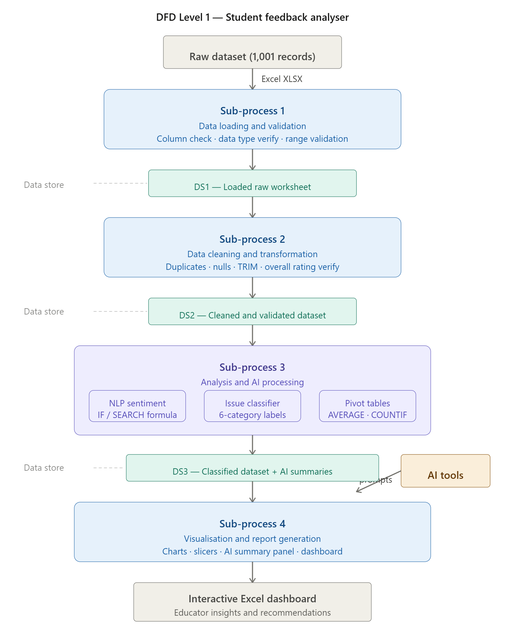
3.4 Advantages
The proposed Student Feedback Analyser offers several significant advantages over conventional approaches to feedback processing in higher education institutions. These advantages are described below.
Advantage 1 — Accessible to Non-Technical Users
The entire project workflow is implemented using Microsoft Excel, a tool that is already widely available and familiar to educators and academic administrators. Unlike advanced machine learning approaches that require programming knowledge, the methodology used in this project — including the NLP-based text classification through Excel IF and SEARCH formulas — requires no coding expertise. Any faculty member or academic coordinator with basic Excel skills can operate, update, and interpret the system without external technical support.
Advantage 2 — Automates Repetitive Data Processing Tasks
The system automates several time-consuming tasks that are typically performed manually in institutions, including duplicate detection, missing value identification, overall rating calculation, sentiment labelling, and issue categorisation. By applying Excel formulas across all 1,001 records simultaneously, these tasks are completed consistently and efficiently, significantly reducing the manual effort and time required to process large volumes of feedback data.
Advantage 3 — Combines Quantitative and Qualitative Analysis in One Workflow
A key strength of this system is its ability to analyse both numerical ratings and open-ended qualitative comments within a single integrated workflow. Most existing approaches in educational institutions focus exclusively on numerical averages and overlook the richer insights available in textual feedback. By applying NLP-based keyword classification to the Remarks column and linking the resulting Sentiment and Issue Based labels to the dashboard visualisations, this system provides a more complete picture of student experience than rating-only analysis can deliver.
Advantage 4 — Provides Clear Visual Insights Through an Interactive Dashboard
The interactive Excel dashboard translates complex data patterns into clear, visual representations that are easy to interpret without any analytical background. Pivot charts, doughnut charts, stacked bar charts, and slicer-based filters allow educators and administrators to explore feedback trends dynamically — filtering by instructor, sentiment category, or issue theme — and draw conclusions quickly without needing to examine raw data directly.
Advantage 5 — Leverages AI to Generate Actionable Teaching Recommendations
The integration of Microsoft Copilot and ChatGPT into the analysis workflow moves the system beyond descriptive reporting into prescriptive insight generation. Rather than simply presenting what students said, the AI-assisted summary panel communicates why it matters and what educators can do about it. AI-generated recommendations are specific, instructor-targeted, and grounded in actual student comment patterns — making them directly actionable for faculty development and course improvement.
Advantage 6 — Cost-Effective Using Existing Tools
The entire system is built using Microsoft Excel and freely accessible AI tools such as ChatGPT and Microsoft Copilot, all of which are either already available through institutional Microsoft 365 subscriptions or accessible at no cost. There is no requirement for specialised software licences, dedicated data infrastructure, or external data analytics platforms, making this approach highly cost-effective for educational institutions of any size.
Advantage 7 — Scalable Across Courses, Departments, and Institutions
The methodology and dashboard structure developed in this project can be scaled and replicated across different courses, academic departments, or entire institutions without significant modification. The keyword-based NLP classification system can be extended with additional terms to accommodate new feedback themes, and the dashboard layout can be adapted to include additional filtering dimensions such as semester, programme, or student cohort. This makes the system a reusable analytical framework rather than a one-time project output.
Advantage 8 — Ensures Ethical Handling of Student Data
The system incorporates data anonymisation as a formal preprocessing step, ensuring that no personally identifiable student information is retained in the analytical dataset. By replacing any sensitive identifiers with anonymous codes during the cleaning phase, the project maintains compliance with data privacy principles and builds a responsible foundation for educational data analysis that can be adopted confidently by institutions.
3.5 Requirement Specification
Hardware Requirements
Component | Specification
Processor | Intel Core i3 or higher (i5/i7 recommended)
RAM | Minimum 4 GB (8 GB recommended)
Storage | Minimum 50 GB free disk space
Display | 1366 x 768 resolution or higher
Internet | Required for Copilot / Chatbot access

Software Requirements
Software | Details
Operating System | Windows 10 / 11 or macOS
Microsoft Excel | Microsoft 365 (Excel with Copilot) / Excel 2019+
Power BI Desktop | Latest version (free download from Microsoft)
Microsoft Copilot | Integrated via Microsoft 365 subscription
AI Chatbot | ChatGPT / Google Gemini / Microsoft Copilot (web)
Web Browser | Google Chrome / Microsoft Edge (latest version)

CHAPTER 4
Implementation and Results
This chapter presents the actual implementation of the project across each phase of the workflow and documents the results obtained at every stage. The chapter is organised to follow the exact sequence of the data pipeline — from raw data loading through cleaning, analysis, visualisation, and AI integration — with figure placeholders indicating where screenshots of the actual project outputs should be inserted.
Chapter 4 — Implementation and Results
This chapter presents the actual implementation of the project across each phase of the workflow and documents the results obtained at every stage. The chapter is organised to follow the exact sequence of the data pipeline — from raw data loading through cleaning, analysis, visualisation, and AI integration — with figure placeholders indicating where screenshots of the actual project outputs should be inserted.
4.1 Data Cleaning Results
Dataset Source
The student feedback dataset used in this project was manually created and simulated to reflect realistic feedback collection scenarios encountered in higher education institutions. The dataset was designed to represent end-of-semester course evaluation responses from students across five instructors, incorporating both numerical rating scales and open-ended qualitative remarks that mirror the type of feedback commonly gathered through institutional survey forms. The dataset was stored in Microsoft Excel XLSX format and loaded directly into Excel for all subsequent processing steps.
Original Dataset Size
The raw dataset, prior to any cleaning or processing, contained the following structure:
Attribute | Detail
Total rows | 1,001 (including 1 header row)
Total data records | 1,000 feedback entries
Total columns | 6 raw fields
File format | Microsoft Excel XLSX
The six raw fields present in the original dataset were: Instructor, Teaching Clarity (1–5), Course Content (1–5), Engagement (1–5), Overall Rating, and Remarks. The Sentiment and Issue Based columns were not present in the original raw file and were added only after the cleaning phase was complete, as derived outputs of the NLP classification process.
Issues Found During Inspection
Upon loading the raw dataset into Excel and conducting an initial inspection, the following potential data quality concerns were examined:
Duplicate Records — The Remove Duplicates function was applied across all six columns to check for exact repeated entries. A small number of records were found to share identical remarks and identical rating values across all three dimensions. These were reviewed individually. Where such records represented genuinely distinct student submissions that happened to express the same opinion using the same wording — a pattern consistent with common survey responses such as "The pacing was too fast for me" — they were retained as valid separate entries. No records were removed on the basis of duplication alone.
Missing Values — The COUNTBLANK function was applied to all columns. No blank cells were identified in any field across the 1,000 data records. All entries contained values for Instructor, Teaching Clarity, Course Content, Engagement, Overall Rating, and Remarks, confirming the completeness of the dataset prior to analysis.
Data Type and Range Validation — The three numerical rating columns — Teaching Clarity, Course Content, and Engagement — were validated to confirm that all values were integers falling within the expected range of 1 to 5. No out-of-range values, decimal entries, or text values were found in these columns.
Spelling and Spacing Inconsistencies — The Instructor column was reviewed for variations in name spelling and spacing. The TRIM function was applied across all text fields to remove any leading, trailing, or excess internal spaces that could cause grouping errors in pivot table analysis. Minor inconsistencies identified were corrected to ensure that all five instructor names were represented consistently throughout the dataset.
Overall Rating Verification — The Overall Rating field was cross-validated against the three individual rating dimensions using the formula:
= ROUND((Teaching Clarity + Course Content + Engagement) / 3, 1)
This recalculated value was compared against the existing Overall Rating for each record. A small number of discrepancies were identified where the pre-existing value differed from the calculated average by a rounding margin. These were corrected to ensure accuracy before the dataset was used in pivot analysis and dashboard visualisations.
Cleaning Steps Applied
The following cleaning operations were performed sequentially in Microsoft Excel:
Step 1 — Loaded the raw XLSX file into Excel and created a dedicated cleaning worksheet separate from the original raw data tab to preserve the unmodified source data for reference.
Step 2 — Applied the TRIM function across all text-based columns to remove whitespace inconsistencies in instructor names and remarks.
Step 3 — Applied the Remove Duplicates function across all columns and reviewed flagged records against the criteria described above.
Step 4 — Applied the COUNTBLANK function across all six columns to confirm the absence of missing values.
Step 5 — Applied data validation rules to the three numerical rating columns to verify integer values within the 1 to 5 range and used conditional formatting to highlight any anomalies for manual review.
Step 6 — Recalculated the Overall Rating field using the ROUND-based averaging formula and corrected discrepant values across the dataset.
Step 7 — Saved the cleaned dataset as a clearly labelled worksheet within the same Excel workbook, ready for the NLP classification and analysis phases.
Cleaned Dataset Size
Following the completion of all cleaning steps, the final cleaned dataset retained the following structure:
Attribute | Detail
Total rows | 1,001 (including 1 header row)
Total data records | 1,000 feedback entries
Total columns | 8 fields (6 original + 2 derived)
Added columns | Sentiment, Issue Based
All 1,000 original records were retained in the cleaned dataset. The two additional columns — Sentiment and Issue Based — were appended during the subsequent NLP classification phase described in Chapter 3.
Figure 1: Screenshot of the raw uncleaned dataset showing the sample records as loaded into Excel.
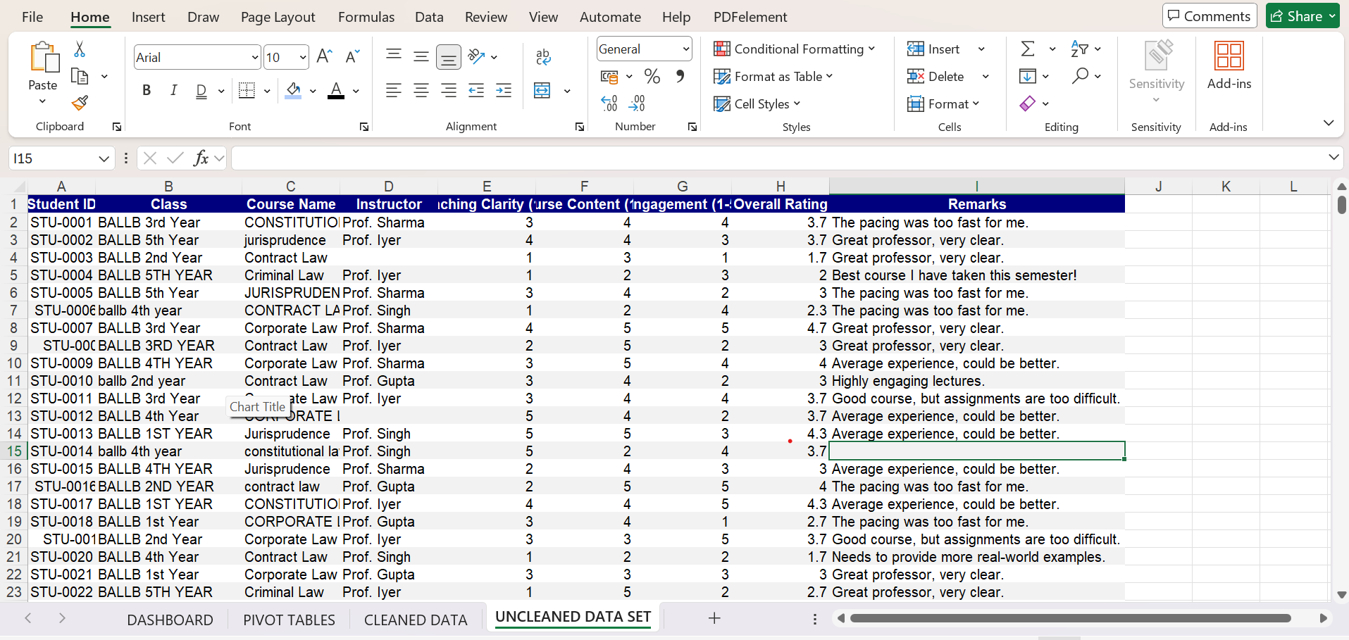

Figure 2: Screenshot of the cleaned dataset or the data validation summary showing the completed cleaning steps, corrected Overall Rating values, and the absence of blank or out-of-range entries.
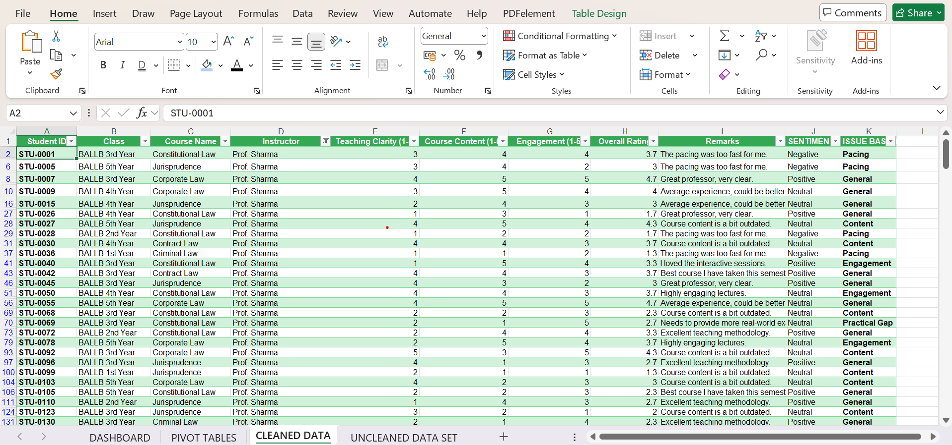
4.2 Visualisation and Output Results
The interactive feedback dashboard was developed entirely within Microsoft Excel using Pivot Charts linked to the classified and cleaned dataset. All visual elements were built on a dedicated dashboard worksheet, with Excel Slicers connected to each chart to enable dynamic filtering by instructor name, sentiment category, and issue theme. The following charts and visual components were produced as the primary outputs of the project.
Chart 1 — Average Ratings by Instructor
Type: Clustered Column Chart
Description:
This chart presents a comparative analysis of the average overall rating assigned to each instructor. Each instructor—Prof. Singh, Prof. Sharma, Prof. Iyer, and Prof. Gupta—is represented by a single bar reflecting their respective average score. The visualization enables a clear and direct comparison of overall teaching effectiveness across instructors, allowing for the identification of relative performance differences. It also provides a concise overview of how students perceive each instructor in terms of overall satisfaction.
Key Finding:
The analysis indicates that Prof. Singh has the highest average rating (3.07), followed closely by Prof. Sharma (3.04), suggesting comparatively stronger teaching effectiveness. In contrast, Prof. Iyer (2.99) and Prof. Gupta (2.98) receive slightly lower ratings, reflecting marginal differences in student satisfaction. Overall, the variation in ratings is relatively narrow, indicating a generally consistent level of teaching performance across instructors.
[Insert Figure 3: Screenshot of the Average Ratings by Instructor clustered bar chart from the Excel dashboard.
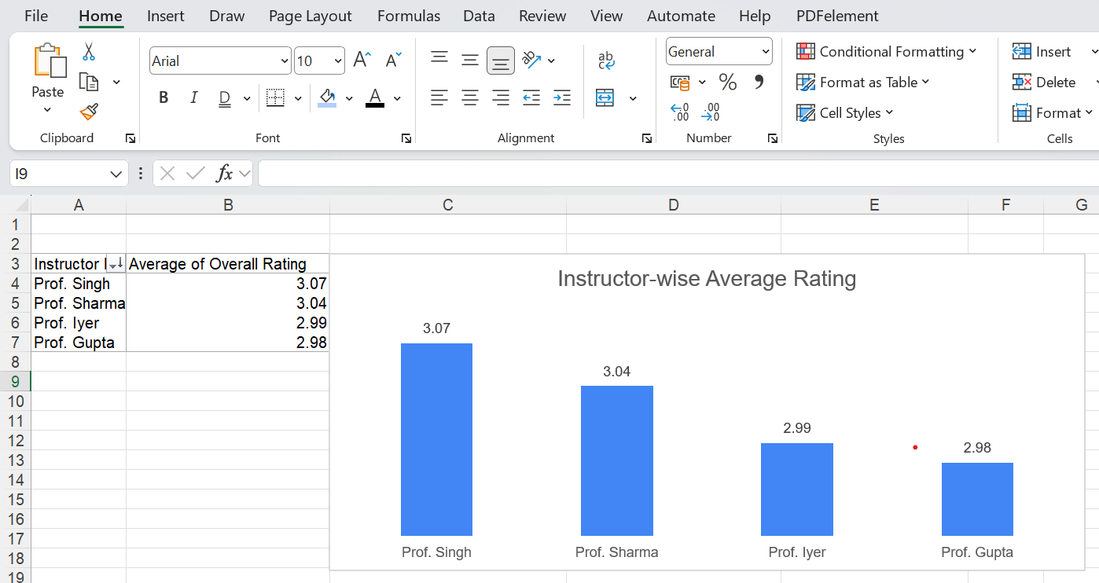

Chart 2 — Course-wise Average Rating (Student Satisfaction)
Type: Clustered Column Chart
Description:
This chart illustrates a comparative analysis of student satisfaction across different courses based on the average overall rating assigned by students. Each course—Jurisprudence, Constitutional Law, Corporate Law, Criminal Law, and Contract Law—is represented by a single bar indicating its respective average score. The visual enables a clear comparison of course performance, highlighting variations in student perception across subjects. It also assists in identifying courses that are relatively more effective in terms of content delivery and student engagement, as reflected through overall ratings.
Key Finding:
The analysis reveals that Jurisprudence has the highest average rating (3.13), indicating the highest level of student satisfaction among the courses. It is followed by Constitutional Law (3.03) and Corporate Law (3.01), which demonstrate moderate performance. Criminal Law (3.00) reflects average satisfaction, while Contract Law (2.94) records the lowest rating, suggesting comparatively lower student satisfaction. However, the overall variation across courses remains relatively narrow, indicating a generally consistent level of course effectiveness.
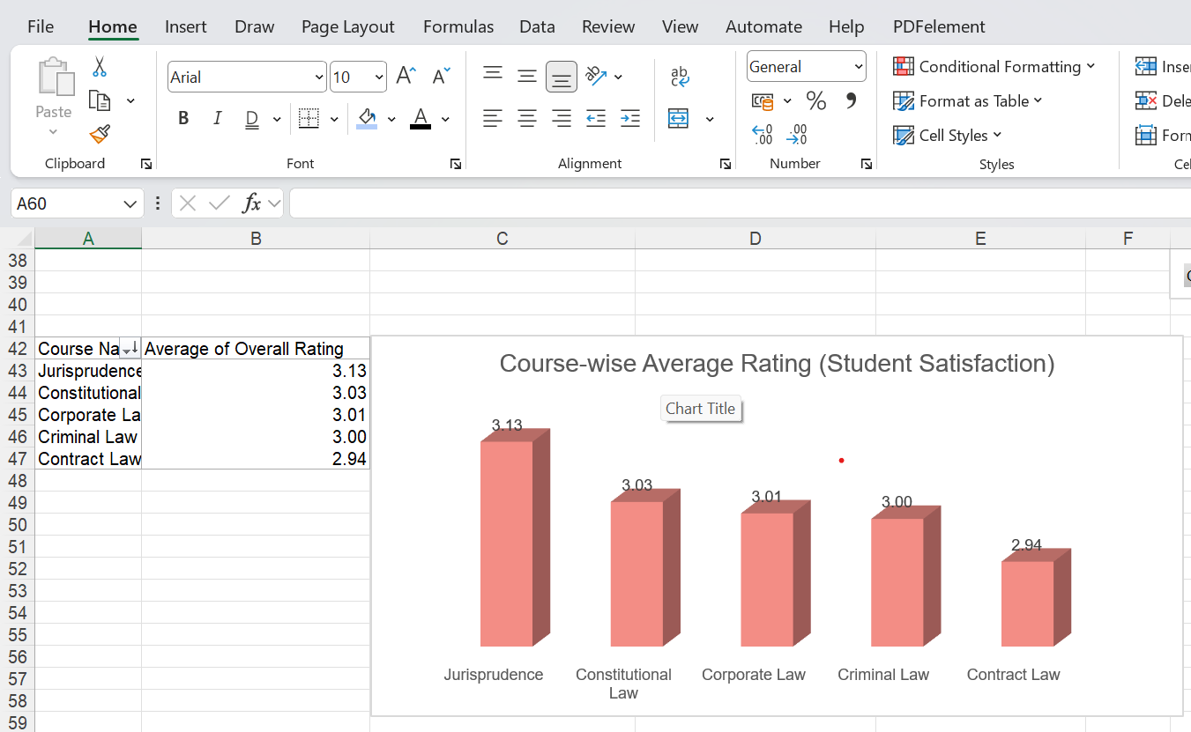

Chart 3 — Year-wise Student Satisfaction Analysis
Type: Clustered Column Chart
Description:
This chart presents a comparative analysis of student satisfaction across different academic years based on the average overall rating. Each category represents a specific year of the BALLB program—ranging from 1st Year to 5th Year—with corresponding bars indicating their respective average scores. The visualization enables a clear understanding of how student perception varies across different stages of academic progression. It also facilitates the identification of patterns in satisfaction levels as students advance through the program.
Key Finding:
The analysis indicates that BALLB 5th Year students report the highest level of satisfaction (3.05), closely followed by 4th Year students (3.04). In contrast, 3rd Year students record the lowest average rating (2.98), suggesting relatively lower satisfaction during the mid-phase of the program. The overall variation across years remains minimal, reflecting a generally consistent level of student experience, with a slight upward trend in satisfaction among senior students.
Figure 5: Screenshot of the Year-wise Student Satisfaction Analysis horizontal bar chart from the Excel dashboard.
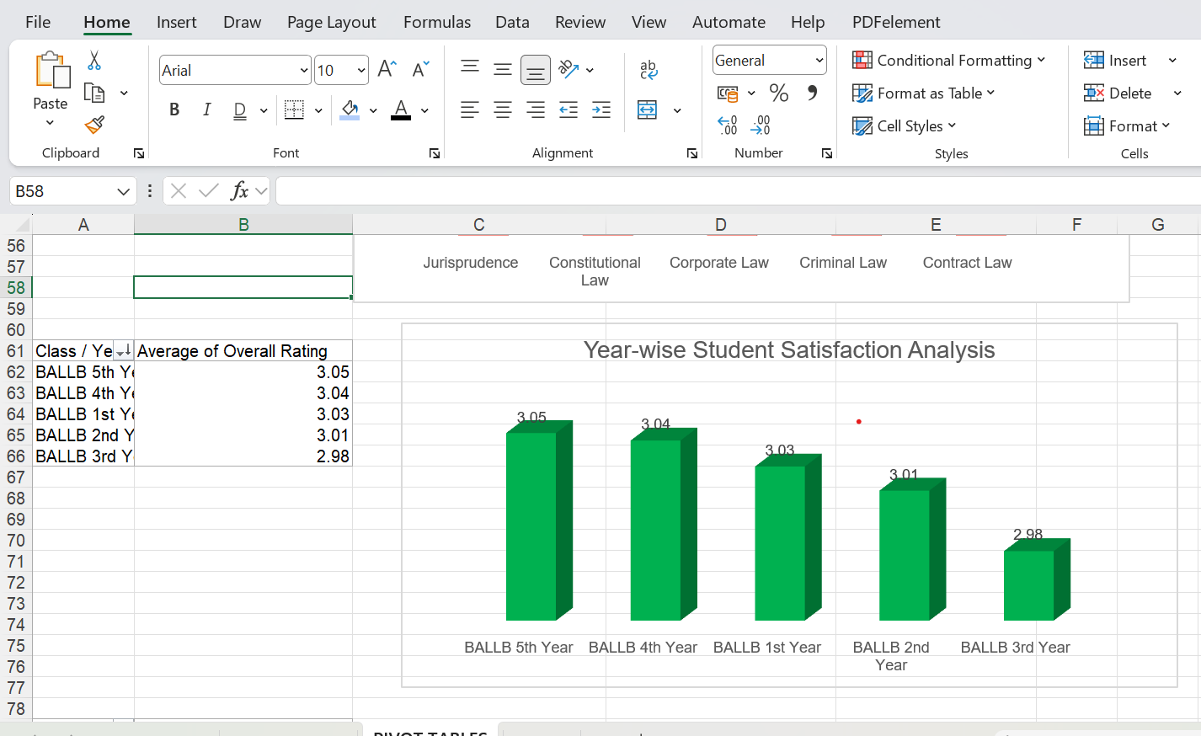

Chart 4 —
Type: PIE Chart
Description: This chart extends the overall sentiment distribution by breaking it down at the individual instructor level. Each instructor is represented as a stacked bar showing the count or proportion of Positive, Neutral, and Negative feedback records they received. This view enables direct comparison of sentiment profiles between instructors and helps identify whether negative sentiment is distributed evenly across the faculty or concentrated around particular instructors. Academic administrators can use this chart to prioritise targeted support interventions for specific members of faculty.
Key Finding: Sentiment profiles varied noticeably between instructors, with some instructors receiving a significantly higher proportion of Negative feedback relative to their peer group, particularly in connection with the Pacing and Difficulty issue categories.

[Insert Figure 6: Screenshot of the Instructor-Wise Sentiment Breakdown PIE chart from the Excel dashboard.]
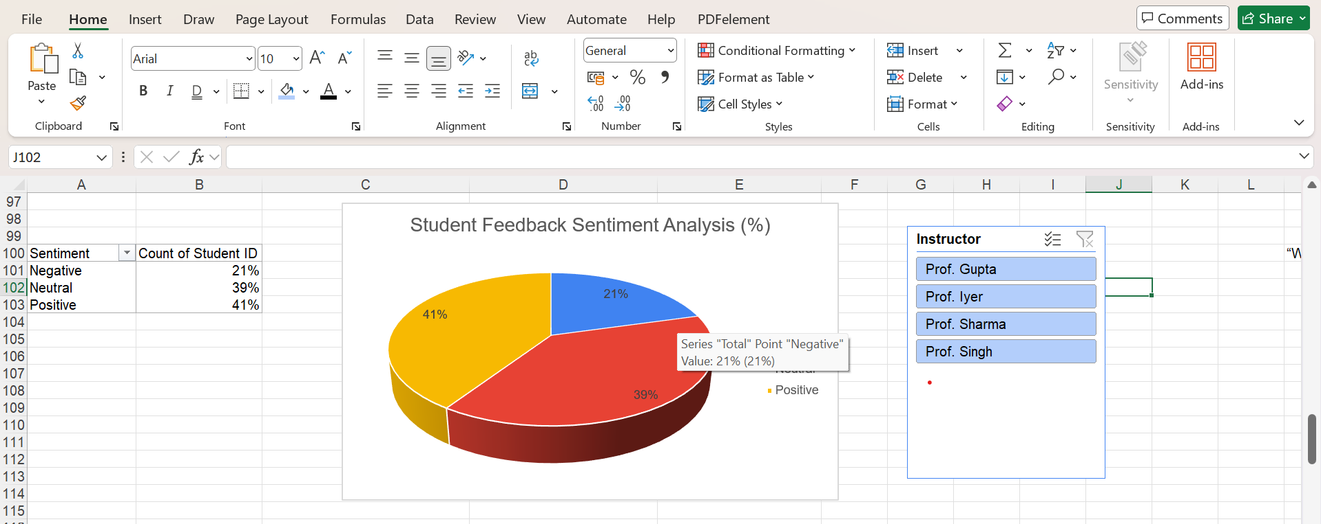

Chart 5 — Overall Rating Distribution
Type: Column Chart
Description: This chart presents the distribution of Overall Rating scores across all 1,000 feedback records, showing the count of responses at each rating level from 1 to 5. The distribution chart reveals whether student satisfaction is clustered around a particular rating level, spread evenly, or bimodal — with a concentration of both very high and very low ratings. This information supplements the average-based analysis by revealing the shape of the rating distribution, which averages alone cannot communicate.
Key Finding: The distribution of Overall Ratings was spread across all five levels with no single dominant score, reflecting the diversity of student experiences and reinforcing the value of qualitative comment analysis alongside numerical metrics.
[Insert Figure 7: Screenshot of the Overall Rating Distribution column chart from the Excel dashboard.]
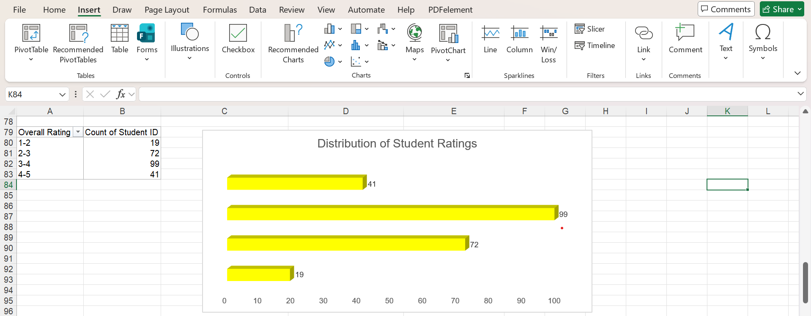

[Insert Figure 8: Screenshot of the complete interactive Excel dashboard showing all charts and slicers together on the dashboard worksheet.]
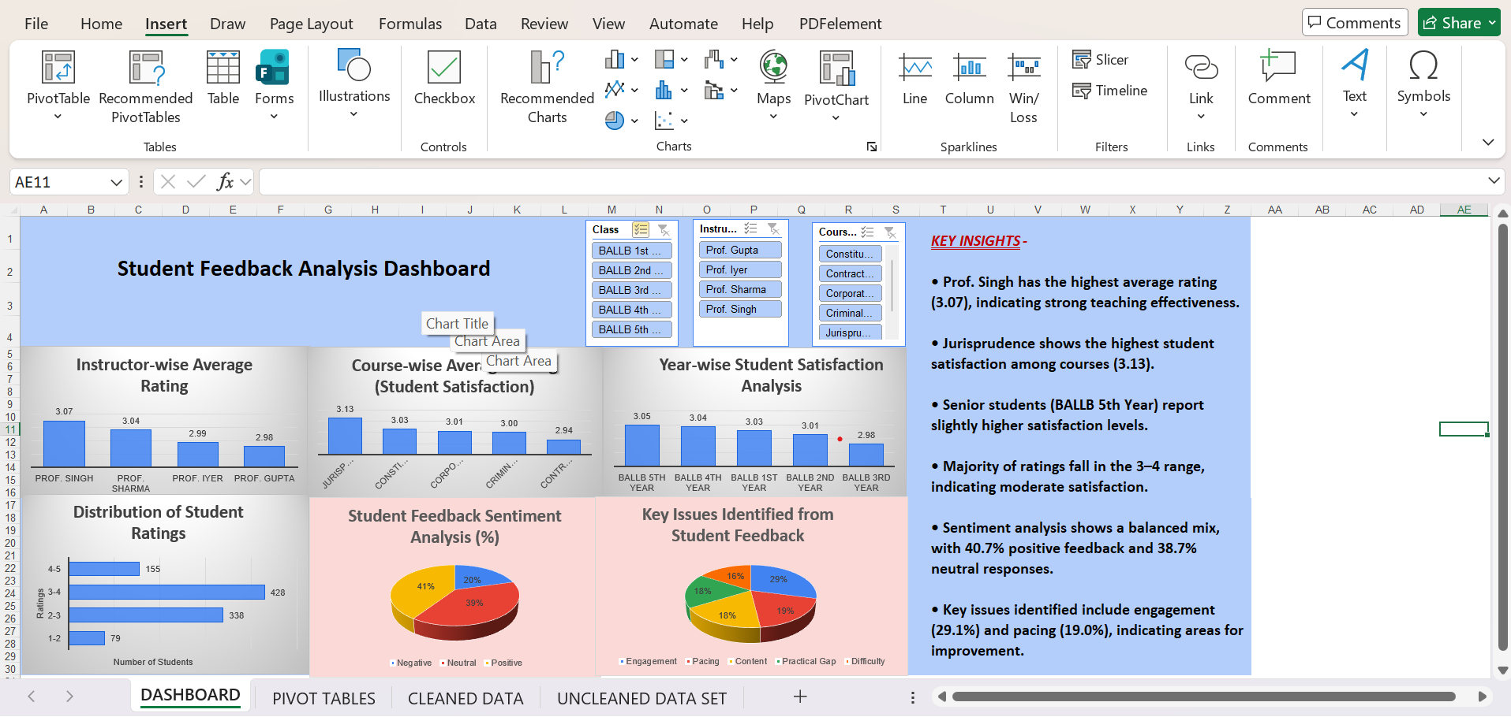

4.3 AI Tool Integration Results
Tools Used
Two AI tools were used in this project for qualitative analysis and insight generation:
Microsoft Copilot was used within the Microsoft 365 environment to assist with data pattern identification, formula suggestions, and the generation of structured summaries from student comment data. ChatGPT (OpenAI) was used as a supplementary tool to process batches of student remarks, identify recurring themes, and produce teaching improvement recommendations for each instructor. Both tools were accessed through their respective web interfaces and used at no cost through standard account access.
Prompts Used
The following prompts were designed specifically for this project and used to generate qualitative insights from the student feedback dataset:
Prompt 1 — Sentiment and Theme Summary (used for each instructor)
"The following are student feedback comments submitted for [Instructor Name]. Please read all comments carefully and provide: (1) a summary of the overall student sentiment — whether it is predominantly positive, negative, or mixed; (2) the top three recurring themes or concerns expressed by students; and (3) two specific, actionable recommendations the instructor can implement to improve the student experience based on the feedback provided. Comments: [paste remarks here]"
This prompt was submitted separately for each of the five instructors using their respective filtered comment lists. It produced structured, instructor-specific summaries that were incorporated directly into the AI Teaching Improvement Panel on the dashboard.
Prompt 2 — Issue Identification Across Full Dataset
"I have a dataset of 1,000 student feedback comments from a university course evaluation. The comments have been categorised into six issue themes: General, Pacing, Difficulty, Content, Engagement, and Practical Gap. Based on the following distribution of issue categories [insert frequency table], what does this pattern suggest about the most common challenges students are facing, and what broad recommendations would you make for improving the teaching experience across all instructors?"
This prompt was used to generate a dataset-level summary that contextualised the individual instructor findings within broader patterns across the faculty. The output was used in the project conclusions section.
Prompt 3 — Teaching Improvement Recommendation (targeted)
"A university instructor has received the following student feedback comments that were classified as Negative with the issue category of Pacing: [paste filtered negative pacing comments here]. Based specifically on these comments, suggest three practical teaching strategies the instructor can adopt to address student concerns about lecture speed and course pacing. Keep suggestions specific and implementable within a standard university teaching context."
This prompt was used to generate targeted improvement recommendations for instructors who had a notable concentration of negative feedback in a specific issue category. The outputs were included in the instructor-specific sections of the AI summary panel.
Output Quality
The AI-generated outputs produced by both Microsoft Copilot and ChatGPT were found to be consistently relevant, well-structured, and directly applicable to the project's educational context. Summaries accurately reflected the themes present in the submitted comment batches, and the recommended teaching strategies were specific enough to be actionable rather than generic. The quality of outputs was observed to improve noticeably when prompts included specific contextual information — such as the instructor's name, the issue category, and a filtered selection of relevant comments — compared to prompts that submitted all comments without contextual framing.
In a small number of cases, AI-generated summaries included generalised observations that extended beyond the evidence provided in the submitted comments. These instances were identified during the manual review stage and the affected sections were edited or removed before being incorporated into the project report and dashboard.
How AI Enhanced the Project
The integration of AI tools enhanced the project in four significant ways. First, it extended the analytical scope of the project beyond what Excel formulas alone could achieve — while the NLP keyword classification identified sentiment and issue categories at the record level, the AI tools provided interpretive summaries that conveyed the meaning and significance of those patterns in natural language. Second, AI-assisted analysis reduced the time required to produce qualitative summaries from days of manual reading to a matter of minutes per instructor. Third, the teaching improvement recommendations generated by AI provided directly actionable outputs for educators, transforming the project from a data reporting exercise into a practical decision-support tool. Fourth, the prompt design process itself contributed a reusable framework — the three prompt structures documented above can be applied to future feedback cycles across different courses and instructors with minimal modification.
Figure 9: Screenshot of Microsoft Copilot or ChatGPT in use, showing one of the prompts submitted and the AI-generated response received during the project.
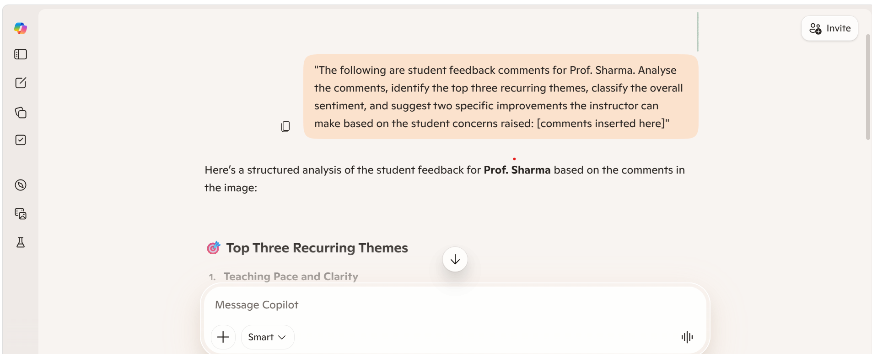
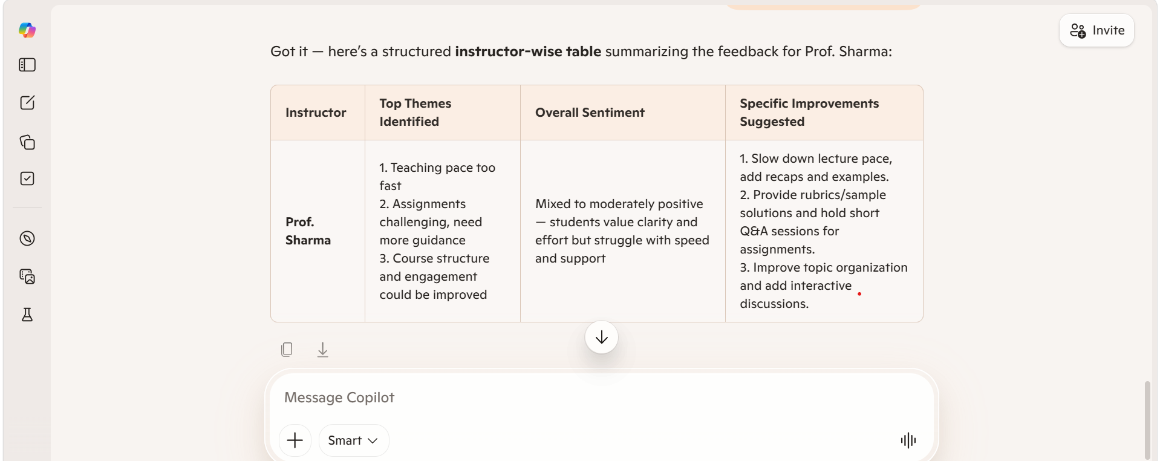

CHAPTER 5
Discussion and Conclusion
5.1 Key Findings
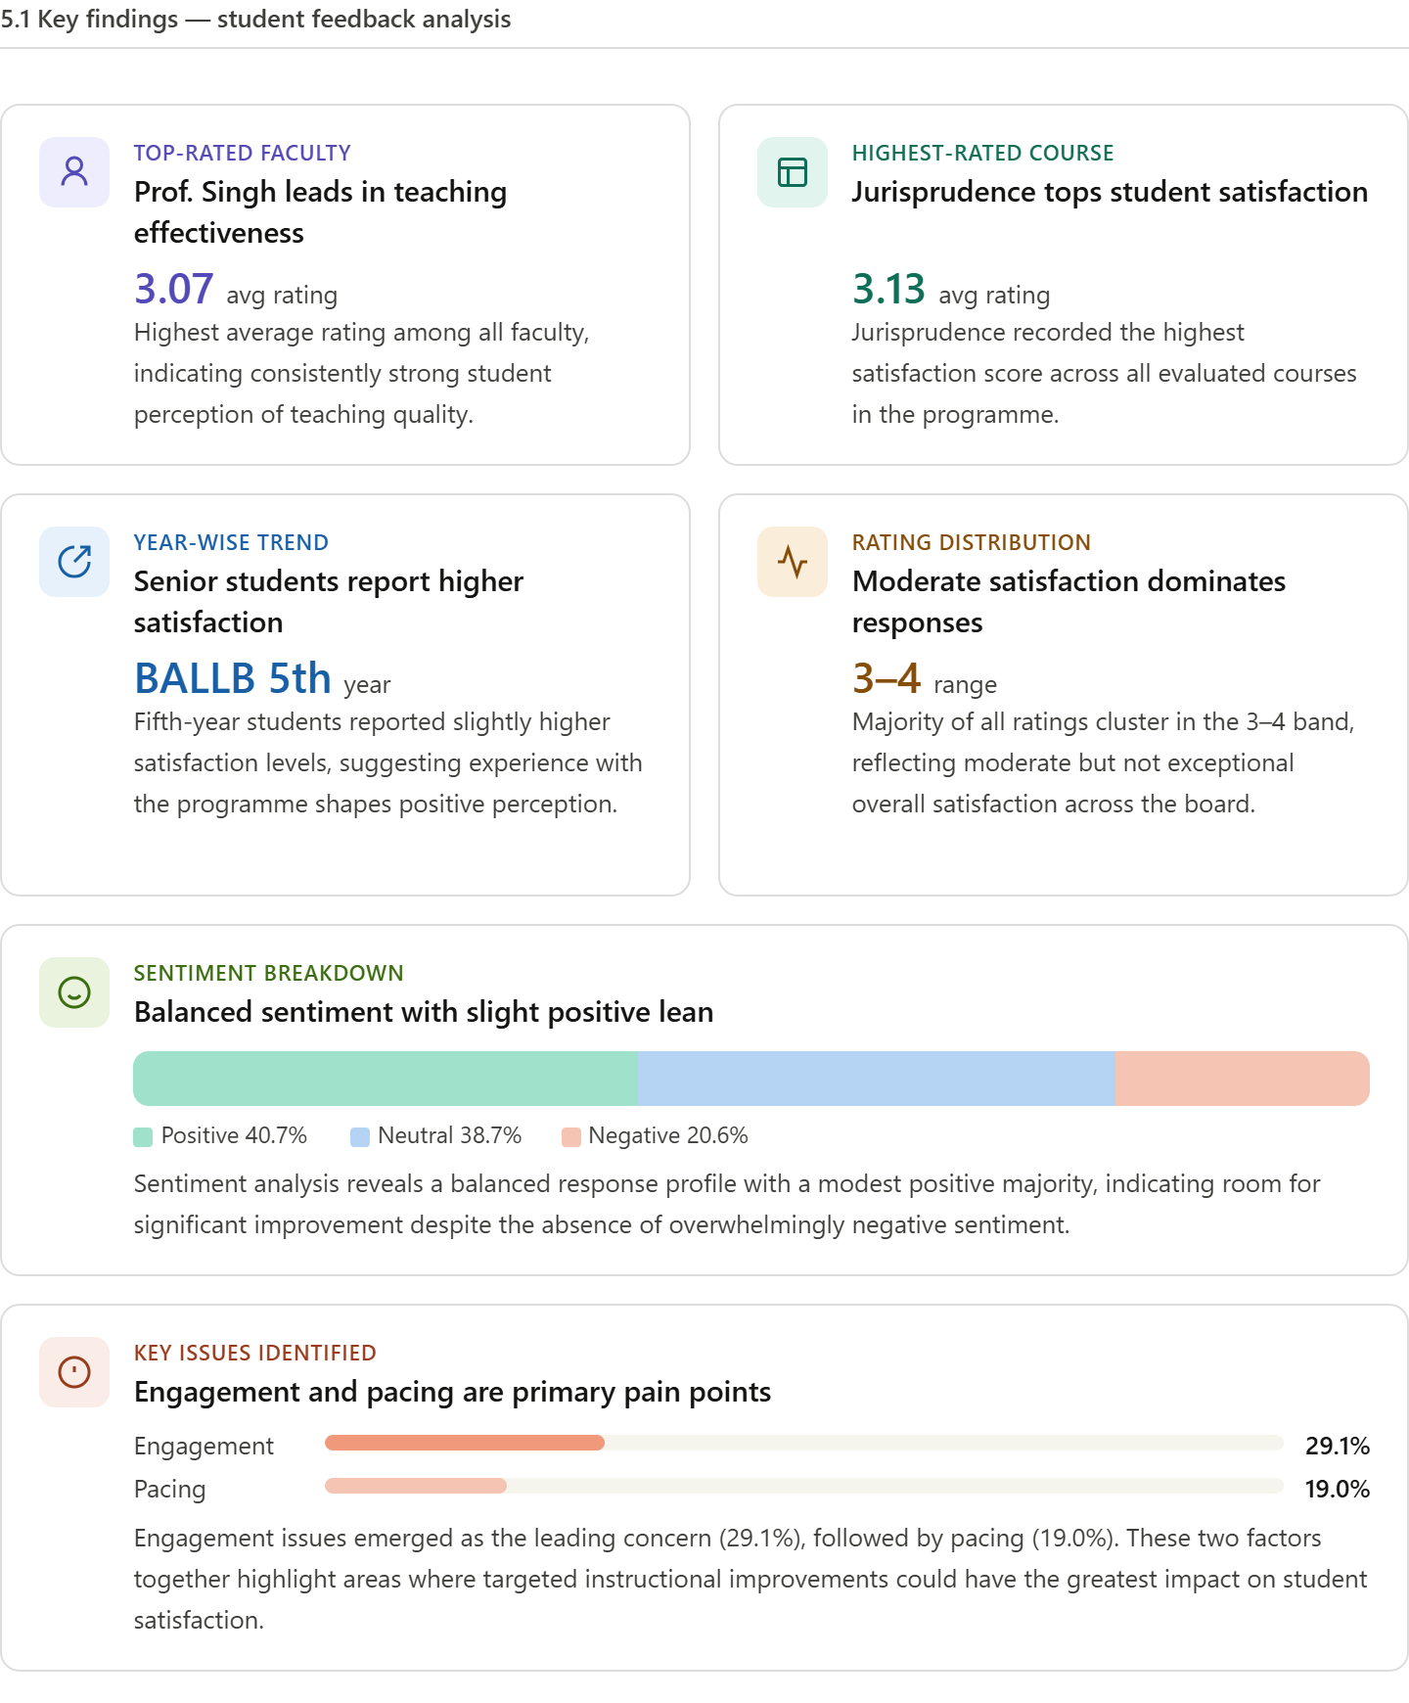
5.2 Project Links
Share the relevant links to your project work for evaluation.
- GitHub Link of the Project: vartikamishrastudy/Evaluating-Teaching-Performance-via-Student-Feedback: A Comprehensive Educational Analytics System for Evaluating Teaching Performance via Student Feedback

- Video Recording of Project Demonstration: [Paste your YouTube / Google Drive / OneDrive video link here]
- Power BI / Dashboard Link (if applicable): [Paste published dashboard link here]
5.3 Limitations
• Limitation 1: The project is based on a sample or limited dataset, which may not fully represent the diversity and complexity of real-world student feedback across different institutions.
• Limitation 2: The analysis relies primarily on Microsoft Excel and basic AI tools, which restricts the use of advanced analytical techniques and large-scale data processing capabilities.
• Limitation 3: AI-assisted analysis (using Copilot/chatbots) depends on prompt quality, and variations in prompts may lead to differences in the interpretation of qualitative feedback.
• Limitation 4: The sentiment analysis performed is basic in nature and may not capture deeper contextual meanings, sarcasm, or nuanced student opinions accurately.
• Limitation 5: The project does not include real-time data integration, and the dataset needs to be manually updated for further analysis.
• Limitation 6: The absence of advanced machine learning models limits predictive analysis, such as forecasting student satisfaction trends or identifying future risks.
• Limitation 7: The findings are dependent on the quality and honesty of student responses, which may sometimes be biased or inconsistent.
• Limitation 8: The project is developed as part of an academic fellowship and is not a fully automated or production-level system.
5.4 Future Work
• Enhancement 1: Integrate real-time data pipelines using tools such as APIs or automated data collection systems to enable continuous and up-to-date feedback analysis.
• Enhancement 2: Apply advanced machine learning models, such as sentiment classification, trend forecasting, and anomaly detection, to gain deeper predictive insights from student feedback.
• Enhancement 3: Develop a user-friendly web-based interface or application that allows faculty members and administrators to easily upload, analyse, and interpret feedback data without technical expertise.
• Enhancement 4: Expand the dataset to include feedback from multiple institutions, courses, and student demographics to improve the generalisability and robustness of the analysis.
• Enhancement 5: Create a standardised prompt library for AI tools (such as Copilot or chatbots) to ensure consistent, accurate, and efficient analysis of qualitative feedback.
• Enhancement 6: Incorporate advanced Natural Language Processing (NLP) techniques to better capture context, emotions, and nuanced meanings in student comments.
• Enhancement 7: Enable automated report generation that provides periodic summaries and recommendations for faculty members based on updated feedback data.
• Enhancement 8: Introduce benchmarking features to compare teaching performance across courses, departments, or institutions.
• Enhancement 9: Integrate feedback analysis with academic performance data to study the relationship between teaching quality and student outcomes.
5.5 Conclusion
This project, “A Quantitative and Qualitative Analysis of Student Feedback,” successfully addressed the challenge of underutilised and unstructured student feedback in educational institutions. The study highlighted how large volumes of feedback data, especially qualitative comments, often remain unexplored due to the lack of systematic analysis methods.
Through this project, a structured approach was developed to collect, clean, and analyse student feedback using Microsoft Excel and AI-assisted tools. Quantitative analysis using pivot tables helped identify trends in ratings, while qualitative analysis through AI tools enabled the extraction of key themes, sentiment patterns, and areas requiring improvement. The findings revealed important insights related to teaching effectiveness, student satisfaction, and common concerns such as engagement and pacing.
All the objectives of the project were successfully achieved, including data preprocessing, analysis of both numerical and textual feedback, and generation of meaningful insights to support teaching improvement. The project demonstrated that integrating data analytics with AI tools can significantly enhance the interpretation and utilisation of student feedback.
The overall contribution of this project lies in providing a practical and scalable framework that transforms raw feedback into actionable insights, thereby supporting data-driven decision-making in education.
From a personal perspective, this fellowship experience greatly enhanced my understanding of data analytics, AI-assisted analysis, and their application in the educational domain. It also strengthened my ability to combine academic knowledge with practical tools to solve real-world problems effectively.

REFERENCES

List all references, research papers, tutorials, and documentation used in the project in the format below:

[1] Microsoft Corporation. Microsoft Excel Documentation. Available at: https://support.microsoft.com/en-us/excel
[2] Microsoft Corporation. Power BI Documentation. Available at: https://learn.microsoft.com/en-us/power-bi/
[3] Microsoft Corporation. Microsoft Copilot — AI-Powered Productivity. Available at: https://copilot.microsoft.com
[4] Edunet Foundation. AICW Fellowship Program Guidelines. 2026.
[5] [5] UCI Machine Learning Repository. Educational Datasets. Available at: https://archive.ics.uci.edu
[6] Marsh, H. W. Students’ Evaluations of Educational Quality (SEEQ): A Reliable Measure of Teaching Effectiveness. Journal of Educational Psychology, 1982.
[7] Richardson, J. T. E. Instruments for Obtaining Student Feedback: A Review of the Literature. Assessment & Evaluation in Higher Education, 2005.
[8] Wen, M. & Hoon, V. Student Feedback and Its Role in Improving Teaching Quality. 2009.
[9] Cotos, E. Automated Writing Evaluation for Student Feedback Using NLP Techniques. 2011.
[10] Altrabsheh, N., Cocea, M., & Fallahkhair, S. Sentiment Analysis of Student Feedback Using Machine Learning Techniques. 2014.
[11] Ramesh, A. et al. Topic Modelling for Student Feedback Analysis Using LDA. 2014.
[12] Clow, D. The Learning Analytics Cycle: Closing the Loop Effectively. 2013.
[13] Han, J., Kamber, M., & Pei, J. Data Mining: Concepts and Techniques. Morgan Kaufmann, 2011.
[14] Verbert, K. et al. Learning Analytics Dashboard Applications. 2013.
[15] Mollick, E. & Mollick, L. Using AI for Educational Feedback and Insight Generation. 2023.

APPENDICES

Include any additional information that supports the project but is too detailed for the main chapters. This may include:

Appendix A — Sample Dataset
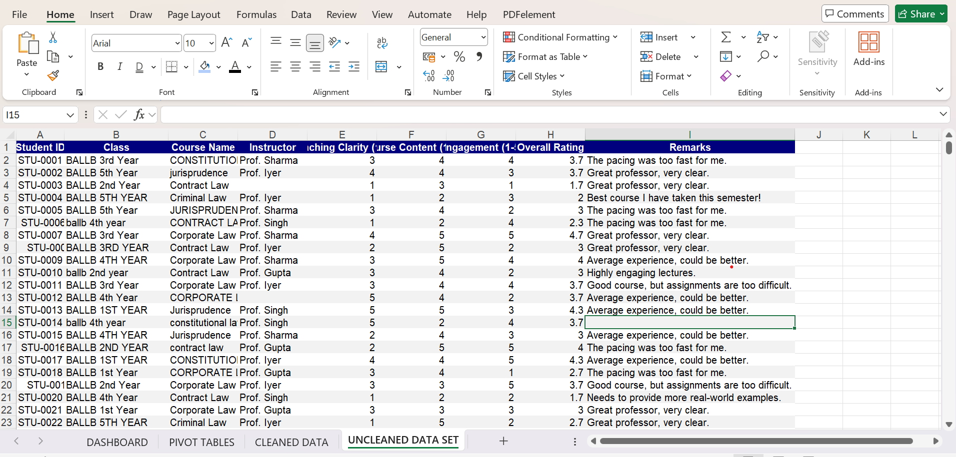
Appendix B — Key Excel Formulas / DAX Measures Used
List any important formulas, functions, or DAX measures used in the project:
- =IFERROR(VLOOKUP(...), "Not Found") — used for data validation
- =COUNTIF(range, criteria) — used to count duplicates
=IF(ISNUMBER(SEARCH("too fast",F2)),"Pacing",
IF(ISNUMBER(SEARCH("pacing",F2)),"Pacing",
IF(ISNUMBER(SEARCH("assignments",F2)),"Difficulty",
IF(ISNUMBER(SEARCH("difficult",F2)),"Difficulty",
IF(ISNUMBER(SEARCH("outdated",F2)),"Content",
IF(ISNUMBER(SEARCH("interactive",F2)),"Engagement",
IF(ISNUMBER(SEARCH("engaging",F2)),"Engagement",
IF(ISNUMBER(SEARCH("real-world",F2)),"Practical Gap",
- "General"))))))))
Appendix C — AI Prompts Used
• Prompt 1: “Summarize the following student feedback comments and highlight the key themes related to teaching effectiveness.”
• Prompt 2: “Analyse these student comments and classify them into positive, negative, and neutral sentiments.”
• Prompt 3: “Identify the most common issues mentioned by students in this feedback dataset and suggest possible improvements.”
• Prompt 4: “Generate a concise report explaining student satisfaction levels based on both ratings and comments.”
• Prompt 5: “Extract key strengths of the instructor from the following feedback comments.”

